Ideation Phase
Empathy Map Canvas

Date | 25 November 2025
Team ID
Project Name | BookStore
Maximum Marks | 4 Marks

Empathy Map – BookStore (For Two User Personas)
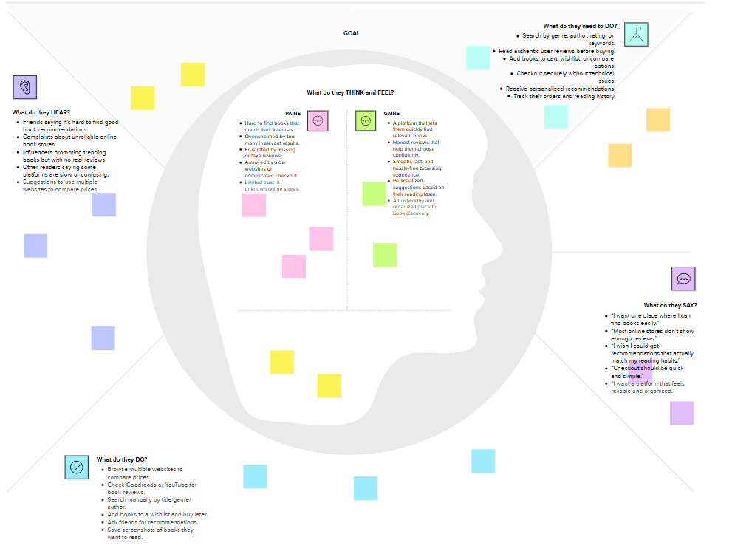

Persona 1 – Bookstore Owner / Manager
Says
I need a simple system to manage books and inventory
I want to know which books are selling well
I want faster billing and better stock updates

Thinks
Manual stock updates take too much time
A system should prevent stockouts and overstocking
Better data can improve sales decisions
Does
Tracks inventory and updates stock
Manages sales, orders, and customer requests
Analyzes best-selling books and adds new arrivals

Feels
Stressed when inventory is inaccurate
Relieved when reports are automated
Confident when the system is organized

Pains
Missing stock and delayed updates
Slow billing and manual processes
Hard to identify fast-selling items

Gains
Centralized inventory management
Real-time stock tracking
Automated reports and faster checkout

Persona 2 – Customer (Book Lover / Online Shopper)
Says
I want to find the book I need quickly
Checkout should be fast and simple
I need to know if a book is available

Thinks
Searching should be easy with clear categories
Reviews help in choosing the right book
I hope I don’t waste time on unavailable books

Does
Searches books by genre, author, or title
Checks availability and compares prices
Adds items to wishlist or buys online

Feels
Frustrated if searching is slow or confusing
Happy when recommendations match preferences
Satisfied with fast and problem-free checkout

Pains
Hard to know availability
Too many options without guidance
Long queues or slow checkout processes

Gains
Quick search results and stock status
Personalized book suggestions
Smooth shopping and easy payment

